

Platinum Series

Preliminary Development Information

Draft updated Oct 06

Introduction.

The challenge for Monitor Audio’s design team was to achieve the most natural sound possible by focusing on every detail, however small or insignificant it may seem. High tech materials and a purist design approach have transformed loudspeaker performance to another level, setting the bench mark for all others to follow. The new Platinum series represents the epitome of British craftsmanship, quality and Monitor Audios’ fine heritage of producing award winning sound.

The Platinum series is the embodiment of refinement, beautiful styling and innovation, coupled with astounding sonic mastery. Progressive development, testing and good old fashioned listening have brought together the key elements required to create the most supremely esoteric speaker systems. Unique materials, driver and cabinet technologies have been designed together and focused to harness our dedication and devotion to music and engineering prowess. Attention to detail is evident in every component part, being machined to exacting standards and only using parts from the very best world class suppliers. Finally, every speaker is carefully hand assembled in England by our small team of technicians and tested in our anechoic to very exacting standards.

Technical Glossary & Definitions

- RDT (Rigid Diaphragm Technology). A core of honeycomb Nomex material is sandwiched by ultra thin skins of C-CAM alloy. These skins are only 40uM thick (typical thickness of a conventional C-CAM tweeter dome or less than half the thickness of human hair). An RDT sandwich construction cone is approximately 150 times more rigid than a conventional C-CAM cone made from one layer of 200uM alloy. The hexagonal honeycomb core is the most effective shape to maintain structural rigidity when used in a bonded laminate composition, being ultimately more rigid than a solid structure and possessing a fraction of the overall mass. The overall aim was indeed to reduce mass and increase cone stiffness in order for the cone to work as a lightning fast piston. The new concave cone geometry has been refined by FEA analysis to provide smooth frequency response and eradicate high frequency break up. These types of composite construction techniques are used in high tech aero-space and automobile racing applications from Fighter jet flooring to Formula 1 racing components. RDT is a unique design, developed specifically by Monitor Audio engineers for the Platinum series.
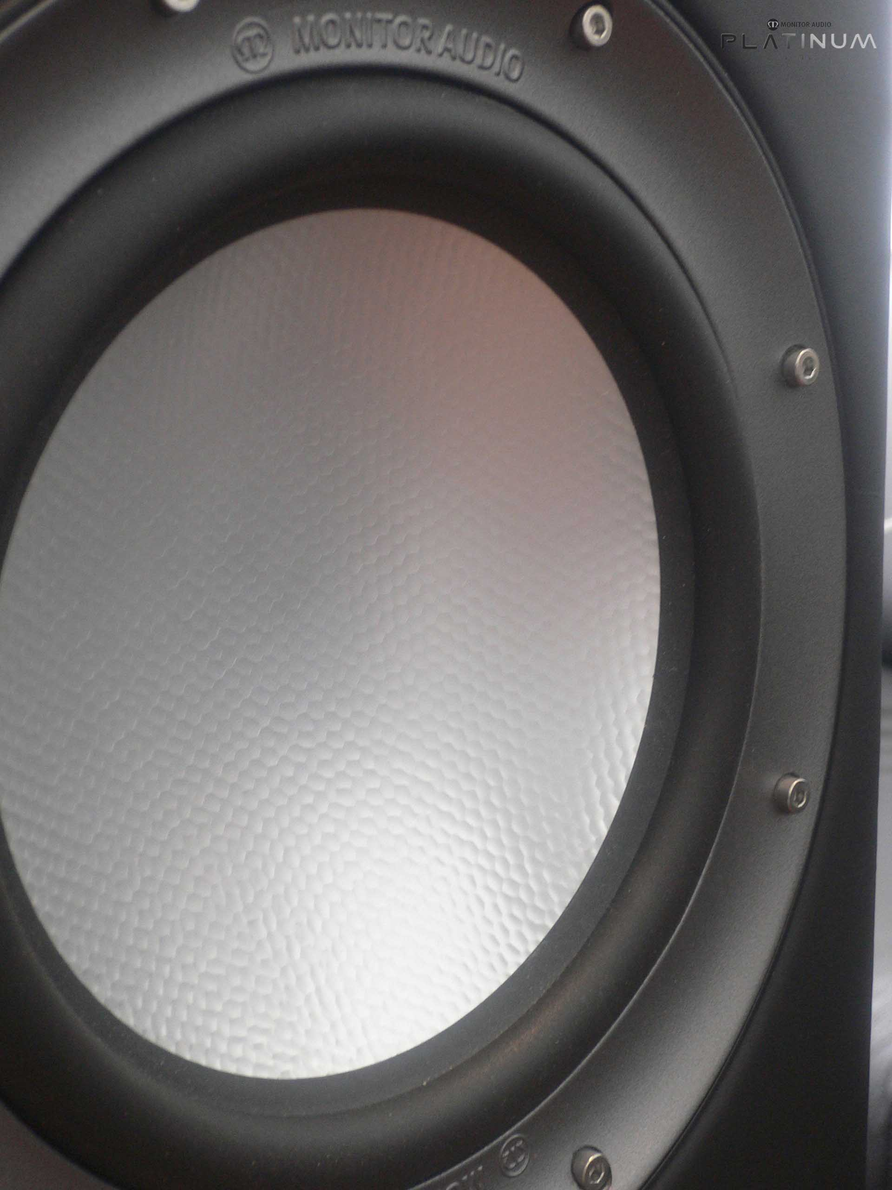
RDT Cone –Internal honeycomb structure can be
seen through the thin alloy skins

- ARC (anti-resonance composite) is a cast thermo-set polymer loaded with minerals to provide very inert, optimally damped components. This type of material is used in high-tech automotive applications and is ideal for high-end acoustic applications where a high degree of structural rigidity and vibration damping is required. Front baffles for all models together with plinths, and the mid-range housings are cast from hi-tech ARC material. ARC is a unique material grade, developed specifically by Monitor Audio engineers for the Platinum series.

- HiVe2. A type new port technology which uses a straight rifled design to accelerate air flow and reduce turbulence. HiVe2 technology has the ability to move air in and out much quicker than a conventional port, the result is fast powerful bass coupled with superior transient response.

- TLE. (Tapered line enclosure) A special tapered parabolic shaped enclosure cast from ARC material, designed to prevent the propagation of standing waves and modal resonance. The tapered shape also has the effect of attenuating high frequencies with smaller waves being suppressed with the use of graduated damping materials. TLE is a unique design, developed specifically by Monitor Audio engineers for the Platinum series.
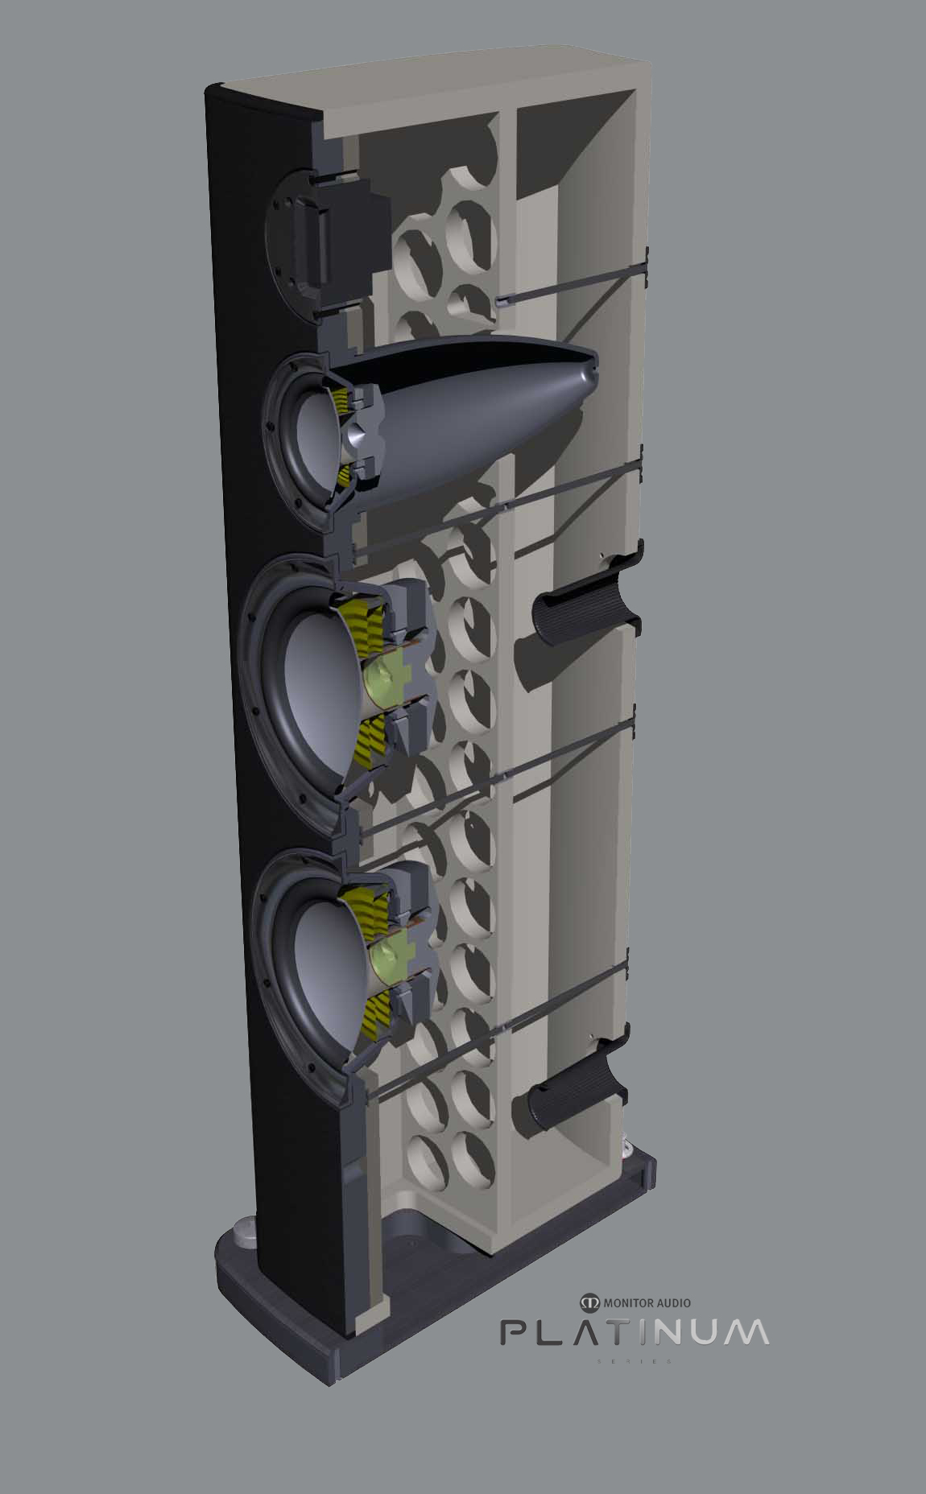
3D cut-away showing the TLE (Tapered line enclosure),
Pin hole and adjacent tie bolt through bracing

- C-CAM. Many years of progressive research and successful use of metal cone technology lead us to the development of C-CAM for use in loudspeaker cones and domes. C-CAM (ceramic coated aluminum /magnesium) is an innovative alloy material originally developed by the aerospace industry for its use in engine components. This material exhibits ideal qualities for use as loudspeaker cones; extremely rigid, yet remains light enough to yield high overall efficiency. C-CAM is formed from an alloy of aluminum and magnesium, which undergoes stress-relieving processes throughout the manufacturing process to avoid surface deformation and molecular weakness. After forming the shape, the cone goes through a high temperature anodic coating process. A layer of pure ceramic (alumina) is depleted onto the surfaces, to give a completely rigid exterior. Conventional cone materials operate in the band with which they start to flex; this can be termed as the break-up, which results in a large amount of audible distortion unless complex crossovers are used. C-CAM cones are designed to have high resistance to bending stress. When formed into a cone, C-CAM material provides increased clarity and reduced distortion compared to conventional cone materials.

