Driver Technology

- Bass/mid range drivers.

All speaker drivers in the Platinum range are unique and are the fruits of our advanced driver research program concentrating on new materials technologies and processes. New die-cast alloy driver chassis feature vented rear section and ultra slim chassis support leg profile with increased open area for low reflection. Computer FEA designed motor systems has resulted in the most linear magnetic circuit design possible. All drivers use focused magnetic gap and copper eddy rings working together to produce a higher level of linearity than was previously possible. These techniques ensure distortion is magnitudes lower than conventional drivers. Magnet plates and poles are CNC machined to very precise standards in order to provide ultimate consistency and tolerances

The dedicated mid-range driver used on the PL300 and PLC350 utilizes an ‘under hung’ voice coil technique to provide maximum linearity and extremely low distortion. High energy NeFeB rare earth magnets are adopted here to provide high efficiency and reduce rear wave reflections. The large 2” (50mm) voice coil is very light and yet it is able to handle huge power input and dynamic impulses. This driver is far from conventional and uses the direct drive RDT cone to provide seamless mid-range and natural integration with the Bass and H.F drivers.

Bass drivers used in the PL100, PL300 and PL350C, all use long throw voice coil windings to provide large excursions at high power levels. 8” bass drivers used in the PL300 and PL350C use dual spider arrangements to provide stability at high excursions. The RDT cones are directly driven by the voice coil and have no dust cap or joints to interfere with the driver response over the working band. The new RDT bass drivers provide stunning dynamics coupled with smooth overall frequency response.

- Gold C-CAM high frequency ribbon transducer.
A pure ribbon tweeter is highly regarded in the world of high-end audio as being the best way to achieve ultra high frequencies and provide the ulitimate in transient response. This is well supported by fundamental physics and indeed one listen will tell you that this driver is something special. Our ribbon design uses an ultra thin enforced sandwich of C-CAM alloy suspended in a powerful transverse magnetic field of high energy NeFeB rare earth magnets. The ribbon serves as both voice coil and radiating diaphragm, with every part of the ribbon driven directly and simultaneously without energy storage. The ribbon H.F transducer provides very fast transient response and is able to start and stop in an instant, perfectly reproducing the leading edge and natural decay of complex musical sounds and their harmonics. The ribbon is capable of ultra wide bandwidth with a useable frequency response to 100 KHz and more than capable of producing sounds and all harmonics for hi-def wide-band formats, such as DVD audio and SACD. Our ribbon diaphragm has a mass of only 18mg, which provides the basis for the remarkable transient response and ultra high frequency extension. Extremely low inter-modulation and harmonic distortion is a testament to the accuracy and linearity of this ribbon transducer.
General Design Overview

All cabinets are built using multiple laminations of wood veneers and shaped to form a rigid ply-wood construction to form a one piece shell, which provides increased rigidity. Internal sides are also non regular and will not allow standing waves to be created. We have developed a unique ‘pin-hole’ internal bracing structure for the Platinum series, positioned to provide rigidity and integrity. Cabinet bracing is further enhanced by steel bolts that tie front and back panels to the ‘pin-hole’ brace. These tie bolts are tightened to a specific torque in order to tune out un-desirable resonances. Bitumastic internal damping material is applied to all internal cabinet walls to provide a further level of resonance damping.

Crossovers have been refined and honed to provide the shortest signal path and use the best quality components available. All components have been selected for the best possible sound quality and involve many hours of listening and evaluation by our engineers. Capacitors are metalised polypropylene film, specially made by ICW clarity cap. High power, low tolerance film resistors are used because they have no residual inductive artifacts. Special air core inductors have been designed to provide low internal resistance and zero distortion.

All front baffles on all products are hand upholstered using Strathspey leather supplied by Andrew Muirhead. Strathspey is the best quality natural leather available and is used in exotic furniture, automotive and marine applications for the most quintessential British names. Soft and luxurious, Strathspey adds a warm tactile feel and provides a traditional, high- quality furniture appearance. In stark contract to its peers the Platinum series melts into any décor with just the right amount of presence.

World renowned WBT Platinum signature terminals have been selected for their precision and are regarded in the industry to be the highest quality terminals available. Ultra finely machined and plated with pure platinum, they provide very low contact resistance and the best possible contact reliability. These terminals feature accurate Micrometer adjustment and are suitable for heavy duty cables with spade, 4mm plug or bare wire connection of all types. Only the most exotic natural wood veneers are used, hand selected, matched and coated with 11 layers of clear gloss piano lacquer. Unlike most other companies, each cabinet is hand veneered after the cabinet structure is made, using very traditional craftsmanship, this ensures precise grain matching and no joint visibility. The beautiful grain definition and rich color variations of Santos Rosewood and natural Ebony make a real statement but alternatively will blend with any interior style or décor. Cabinet finish quality is a work of art and simply exquisite. Machined alloy adjustable spiked feet are used on the PL300, and PL100/ PL350C floor-stands. These feet are meticulously machined from high-grade alloy and anodized to the most exacting quality standards. Solid ‘bullet’ spikes are also hand machined from hi-tensile steel and chrome plated to the very highest mirror finish. For hard or solid wood flooring, a non slip rubber pad is integrated into the foot design.

PL100 Overview

A compact two-way speaker featuring one 6.5” RDT bass-mid driver and C-CAM H.F ribbon transducer. The PL100 produces superior bass definition and articulate mid-range akin to the most accurate studio monitors. The PL100 has the ability however to reach bass frequencies previously unheard of in such a diminutive package. Overall sound balance is tonally accurate and possesses real, lifelike neutrality that is second to none. The rigid cabinet construction, special bracing techniques and damping all add to the acoustic invisibility of the cabinet itself. The sound is not tarnished or masked by the cabinet but is merely an integrated part of the design, adding no detrimental artifacts to the overall sound character.
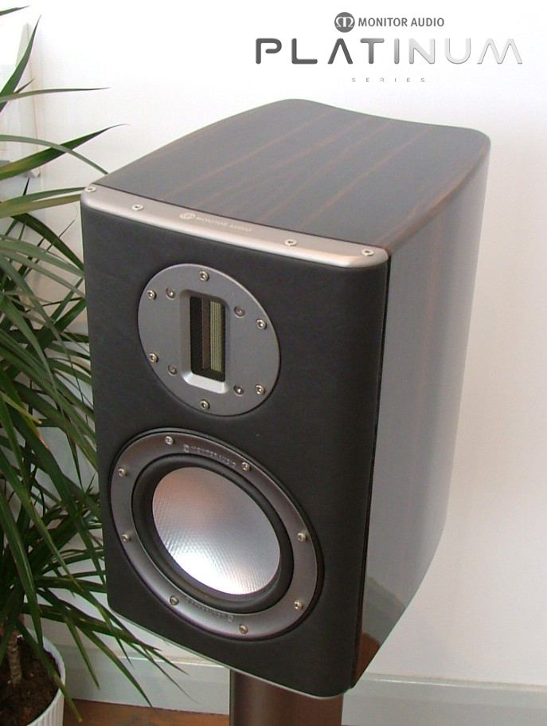

Some of the most accurate speakers ever designed are two-ways and the PL100 follows that tradition and heritage of excellence. However, our application of advanced design and materials have created a compact speaker that surpasses the performance of anything before it, capable of breathtaking power, scale and dynamics that are normally associated with speakers much larger in stature. The sound provided from our C-CAM H.F ribbon transducer is crystal clear and smooth with output extending way past human hearing limits. In fact, with an output reaching to 100 KHz, the PL100 is able to reproduce every harmonic and faithfully replicate the smallest level of detail and nuance. The lightning fast RDT bass driver is capable of producing transient response to match the ribbon H.F transducer, providing consistent phase characteristics right across the entire frequency band. The PL100 is a truly compact, wideband speaker capable of accurately reproducing the most demanding musical passage.
Optional, dedicated floor stands are available, which can be bolted directly to the PL100 cabinet for increased stability and performance. The PL100 stand allows an increased level of tilt to enable optimum set up and positioning. Height is 600mm (24”)

