PL300 Overview
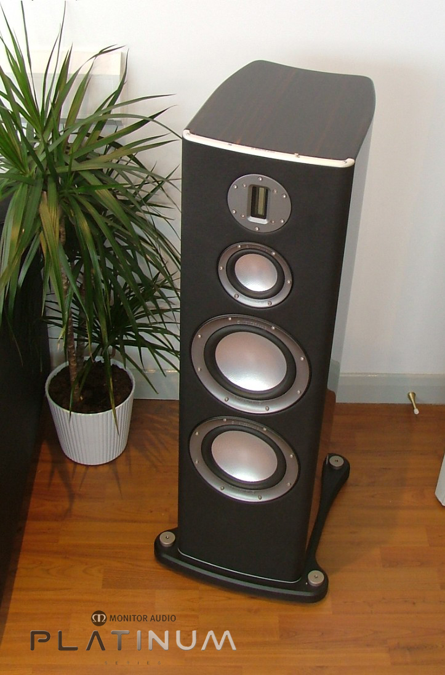
Standing at nearly 1.2M tall the PL300 is a majestic three-way floor-standing loudspeaker comprising 2, 8” RDT bass drivers, one 4” RDT mid-range driver and a C-CAM high frequency ribbon transducer. This ‘top of the range’ reference loudspeaker possesses the ability to create real power and scale required to fill a larger room with amazing sound quality. Whilst the PL300 is able to reproduce jaw dropping dynamics, it’s also agile and adept when required to perfectly reproduce the smallest level of detail. Thanks to our application of advanced technologies, sound balance is neutral, lifelike and totally refined. The PL300 is a true wide-bandwidth speaker system and is able to cover an astonishing frequency spectrum from 28Hz-100 KHz, rendering it as one of the widest range speakers ever conceived which certainly cannot be matched by its peers.

The RDT mid-range driver is dedicated to producing frequencies between 550Hz and 4 KHz with extreme ease and clarity thanks to its ultra light RDT cone. As a result it is able to stop and start with lightning fast precision to provide remarkable transient response. A special mid-range enclosure, TLE (tapered line enclosure) is precision cast from ARC material. This provides a very inert, well damped chamber, its shape specially designed to prevent standing waves being set up. The TLE chamber is decoupled from the main cabinet housing by rubber isolation materials to prevent the transfer of small scale residual energy. The twin 8” RDT bass drivers have been specially designed to produce high excursions, but with extremely low signal distortion. This has been achieved by using specially shaped and optimized motor system arrangements with the application of copper eddy rings to greatly improve linearity. So, even at high power outputs the PL300 remains composed and free from any signs of distortion or fatigue.
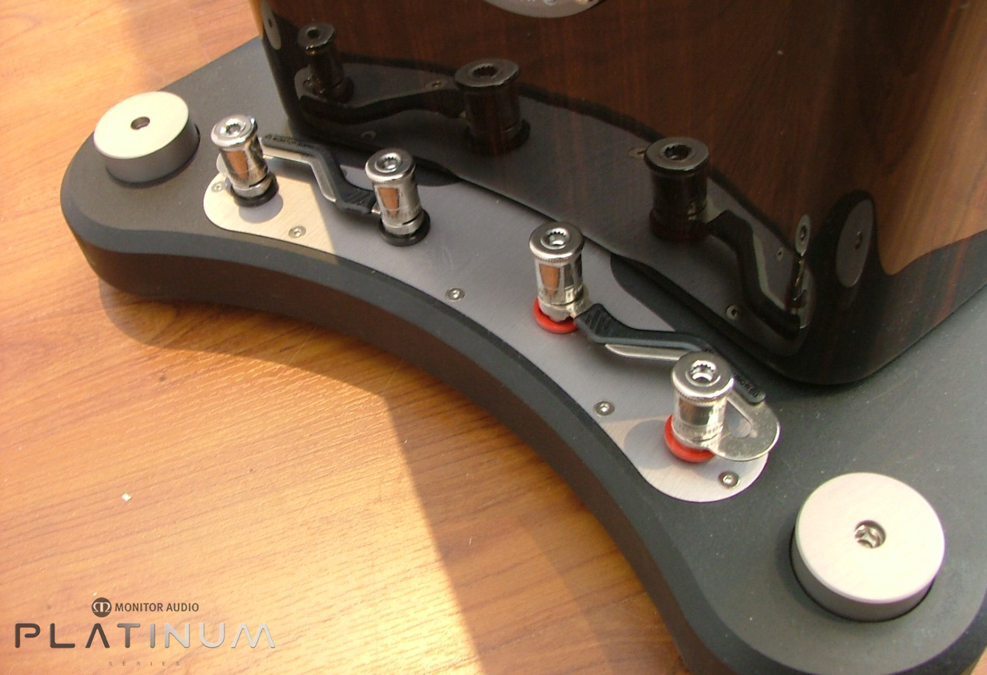

The PL300 also features the unique pin-hole bracing system, tie bolt bracing and bitumastic damping pads applied to all surfaces. The heavy construction has been developed specifically to negate cabinet resonance and provide the ideal level of damping characteristics

PL300’s crossover mounted in the cast ARC plinth to eliminate magnetic interference and provide acoustic de-coupling from the speaker itself, it can therefore regarded as ‘outboard’ The ARC plinth also houses the bi-wire WBT terminals and provides convenient floor level access.

