PLC350 Overview
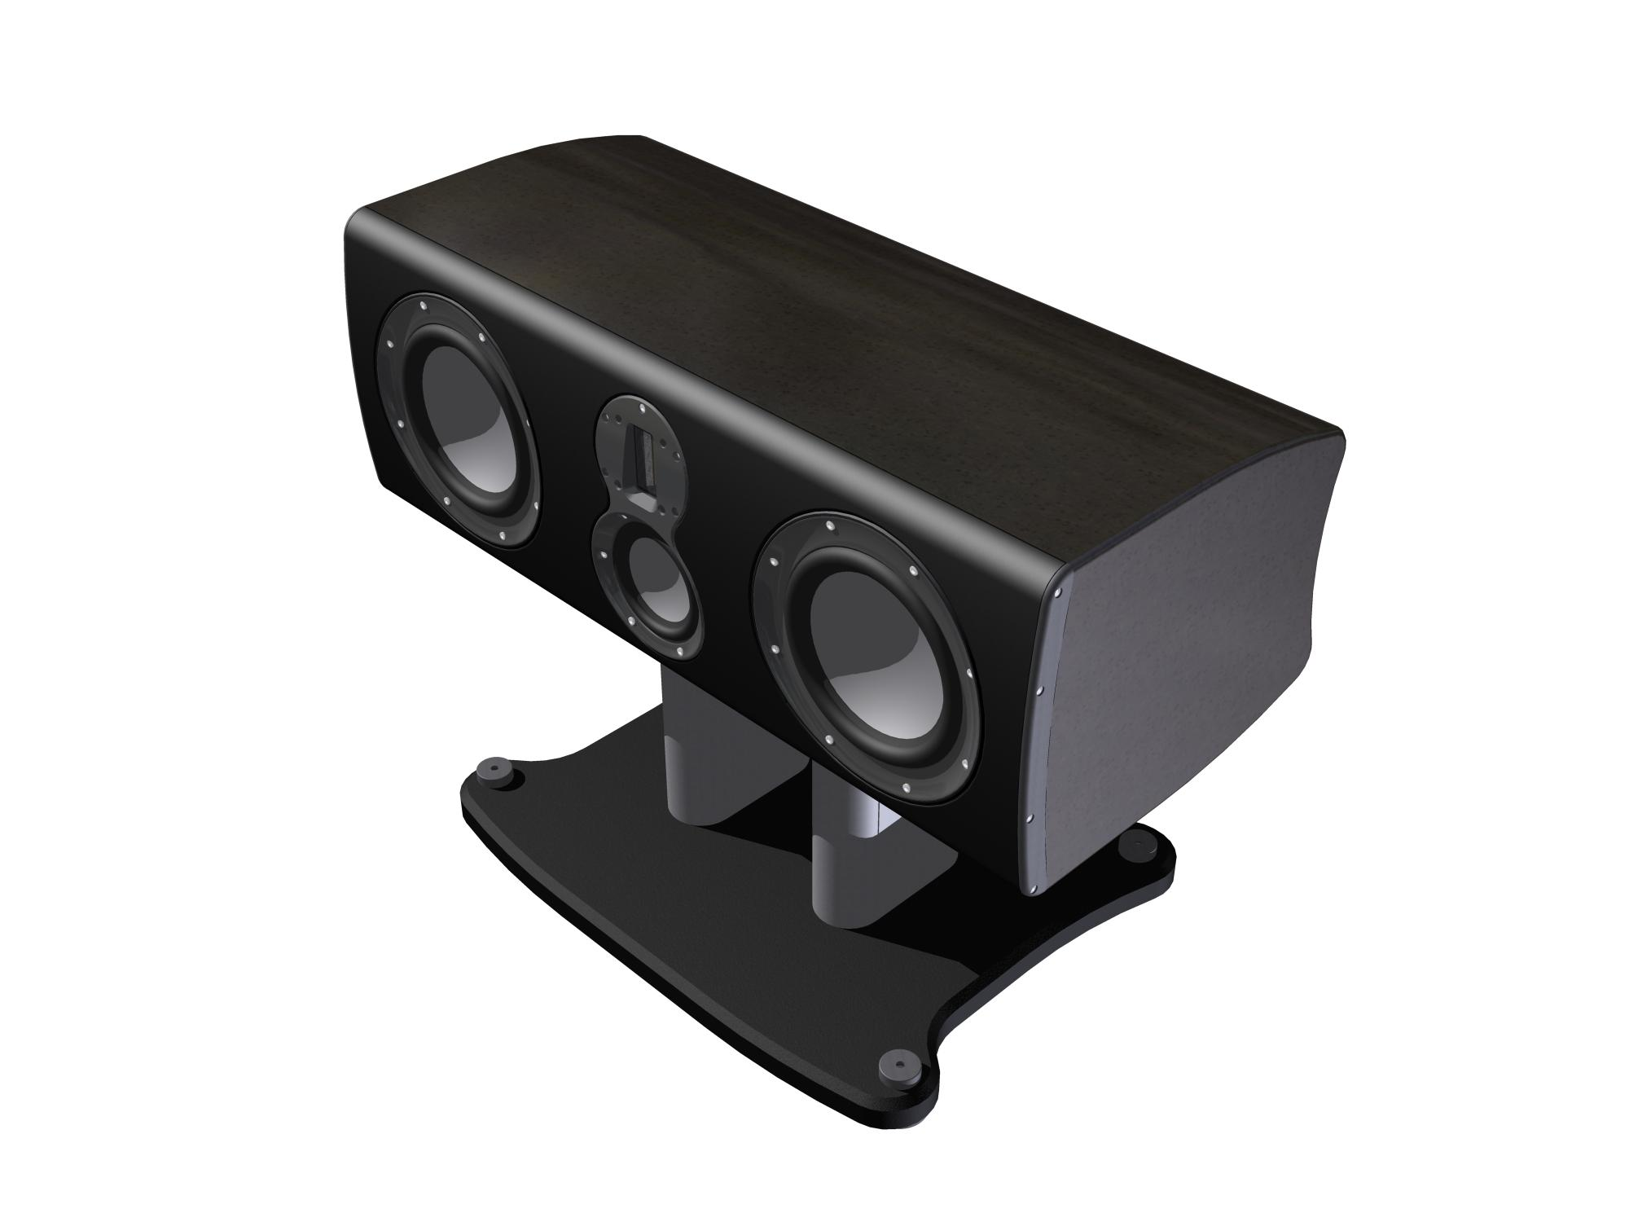
PL350C is large centre 3 –way, four driver centre channel speaker utilizing the same driver compliment as the PL300. The PL350C has the ability to reproduce frequencies from 32Hz-100 KHz; this makes it the widest bandwidth centre speaker available. Neutral tonal balance and sound that is clear from any kind of distortion or resonance makes it perfect for reproducing crystal clear dialogue.

More than 60% of the total sound balance in a theatre system is funneled through the centre channel, that makes it all the more important to make sure it’s up to the job. But just as important, the speaker must be capable of matching the bandwidth and dynamic range of the front/main speakers in the system. Performance and tonal balance from the PL350C is matched to the PLC300, which makes it the ideal choice when building a serious multi-channel audio/ video system.
A dedicated two pillar stand for the PL350C is available to provide straight or tilted positioning to enable optimum set-up. Height is 330mm tall

