Classic No.16.4/ No.16.6/ No.16.8Integrated Tube Hi-Fi Amplifier

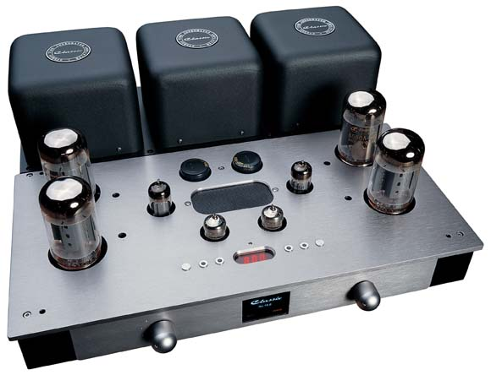
Classic No.16.4, No.16.6 and No.16.8 are three styles of Integrated Tube Hi-Fi Amplifier, newly developed by Classic Audio.
They usethetubes,6L6/KT66（No.16.4）,6550A/KT88（No.16.6）and 2A3（No.16.8）,as PP amplification of final stage.
The three styles adopt the same design of chassis, appearance and basically similar electric circuit. There are just some little distinctions among the three styles, which have different tubes, transformers and circuit parameters.
Let’s take No.16.6（6550A/KT88） as an example to make a brief introduction of the series products.
To get lower distortion and better amplitude-frequency and phase-frequency characteristic, its input stage adopts SRPP circuit consisted of 12AT7.And inverter stage adopts constant-current source mode of long-tailed inverter circuit consisted of integrated circuit and 12BH7, which has a more excellent characteristic of AC balance than a typical long-tailed inverter circuit has, also can reduce phase distortion. This inverter stage also has an enough up-dynamic margin that can improve overall system’s distortionless output power. Final stage is a power amplifier stage consisted of 6550A/KT88, which can be converted between ultra linearity and triode amplifying mode. Grid employs the mode of fixed bias.
It is worth specially speaking of its output transformer that we, , newly developed. With output power 65W（30Hz）and primary impedance 4.5KΩ,it perfectly matches with 6550A.Both its synthetic technology parameter and sound quality have proved that it can bear comparison with some nowadays well-known output transformers in the world. Its primary inductance runs up to 210H（4.5KΩ 50Hz） and it only has a 3.95mH of primary leakage inductance. Primary impedance is exactly flat between 1K—10KHz frequency range and at other frequency rang the impedance’s? variation is slight as well. This transformer’s power frequency response is 5Hz-150KHz(-3dB), primary resonance frequency 240KHz and distributed capacitance below 100Pf. To ensure the transformer has both high function and quality, Classic Audio spares no expense to use the best silicon steel material that is imported from Japanese Nippon Steel, and after being stamped out and tempered by Classic Audio its permeability can be 1.9T. So it is impossible for the silicon steel in general use, Z10 Z11, to be a rival to it. All of these make the transformer have many acoustic advantages, such as deep and clarity bass, full and stout mid-rang, and rigorous and spread high frequency
Because No.16.6 was designed rigorously, reasonable settings like terrestrial current distribution, sampling points of loop negative feedback and local negative feedback make the overall system’s open-loop characteristics have a strong performance. Also because the crossfire signal that goes into signal line is well controlled it can eventually perform give out a clear and precise sound quality.
Although its total loop’s negative feedback is 6dB, due to reasonable design the parameters of overall system still keep a quilt high level
On appearance its design is unique with becoming height. Considering that tubes’ plate current will change within their lifetime, a digital Ia meter is equipped to help users monitor the working mode of the final stage’s tubes. Practice proves that this function is essential for audiophile to have.?
The toroidal power transformer uses Nippon silicon steel Z11. No.16.6 has a high-voltage time-delay circuit for the moment when it is turned on, choking winding, electron filter and remote controller that is shaped from aluminum.
An elegant guard cage is designed to protect tubes. (Note: it needs an extra payment)
No.16.6 Parameters：
Output Power：55W(RMS ultra linearity mode)
25W(RMS triode mode)
Frequency Response: 5Hz-88KHz(-3dB 8W)
Power Frequency Response: 12.5Hz-80KHz(-3dB 55W)
Harmonic Distortion (THD+N):0.21%(1KHz 8W)
0.47%(1KHz 22W)
0.92%(1KHz 55W)
S/N（without weight）:95dB
Input Sensitivity：0.3V(RMS)
Output Impedance：4Ω/8Ω
Static Consumption：130W(220V)
Used Tubes: 6550A*4/12BH7EH*2/12AT7*2
Net Weight: 20Kg
Dimension: 420*337*116

