GW1240
12" Poly Mica Cone Woofer
2" Aluminum Voice Coil
Pressed Steel Frame
Butyl Rubber Edge
Vented Pole Piece
40 Ounce Magnet
Bumper Plate
18-5000 Hz
150 Watts RMS
GW1244  T/S Parameters | 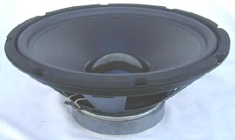
  Symbol | Value
  Z | 4 ohms
  Re | 3.6 Ohms
  Fs | 29.7 Hz
  Qms | 3.301
  Qes | 0.863
  Qts | 0.684
  Vas | 119.6 Ltr
  Sens | 90.9 dB

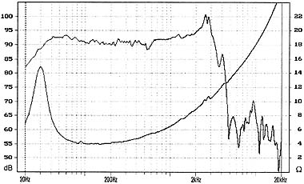
GW1244

