Ribbon Monitor 30
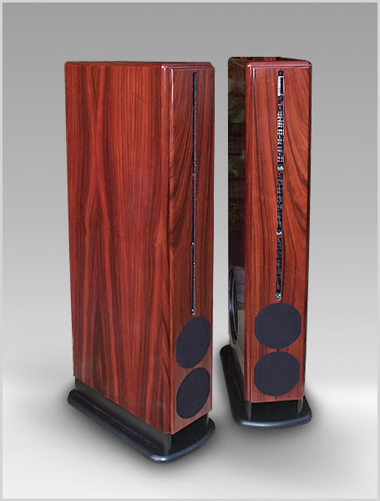
Ribbon Monitor 30M (shown in MLS piano rosewood)
"The RM 30 is a speaker that can match the dynamic capabilities of competent horns, the immediacy of electrostatics and planar-magnetics, and the fine detailing and imaging of the best dynamic designs." - Positive Feedback

RM30 is 50 cm (20") deep, but can be placed directly against a back wall if needed. The FST, Soundcoat and 10" Megawoofer are all standard. M and C versions are exactly the same except for the M's sidefiring woofers. The large cabinet of the C version provides good quality bass flat to 39 Hz from the four 16 cm WCF woofers. The M version cuts off at 32 Hz. The RM30 uses three 2.4 Ohm midrange panels wired in series. The FST is at the top of the column. The C version is a true line source, the M series is a slight departure with its side-firing woofer. The active 16 cm is a specially developed WCF 16 cm Megawoofer. They offer higher power handling, cleaner sound and have the ability of not bottoming out no matter how hard they are driven.
The RM30's are extremely flexible of placement, including touching the back wall if necessary.
VMPS RM30 M & C versions
This loudspeaker answers the requests from audiophiles since early 2002 for a speaker priced between, & more attractive than the RM2 & RM40. Its premium blending of price, performance, flexibility, & cosmetic beauty promises more than anything currently available.
· Price includes Free Swinging Tweeter & SoundCoat.
· Performance: maximum output just below the RM40 combined w/a new reference in staging, imaging, musicality, nearfield listening, & disappearing qualities.
· Flexibility: the standard C model has bass extension in the high 30s. The M version (additional 10”side firing MW, same cabinet) extends to the high 20s & has a feature to minimize bass modes. Details on both versions below.
· Cosmetic Beauty: at 20cm wide it’s the narrowest VMPS ever & 5 cm narrower than the 626R standmount. At 122 cm it’s only 8 cm above the RM2 and a perfect match for video monitors. Depth is a moderate 50 cm.
Driver Array: the sequence below matches the driver positions on the baffle, from the top down.
1. Standard FST tweeter, previously standard only at the RMX.
2. 3 vertical Neo mids.
3. Dual active 16 cm, the ideal diameter in the critical transition range, w/punchy, quick midbass.
Passive Radiators: tunable, down firing, slot & mass loaded (classic VMPS). The ultra-slim baffle requires dual 16 cm PRs (a VMPS first), mounted inline front to back. Mass adjustments are performed on both or only one PR (the front), providing finer & smoother tuning increments.
Woofer Options: apartment dwellers, persons with 1st octave room modes, persons desiring moderate bass extension, &/or persons already possessing a quality subwoofer will be pleased w/the C model’s high 30 Hz cutoff. The M model’s side-firing 25cm 80oz-magnet Megawoofer extends to the high 20 Hz range. The mirror-imaged L-R speakers are reversible, allowing the 25cm basses to fire either inward or outward to maximize the averaging of room modes, a'la RM/X. We generally recommend:
· Smaller rooms &/or short sidewall spacing = basses face inward
· Larger rooms &/or long sidewall spacing = basses face outward

Ribbon Monitor 30M (shown in standard lite oak)
Crossovers: bass LP/midrange HP & Biamp/Bi-wire split @ 280 Hz, midrange LP/tweeter HP @ 6.9 kHz.
Sensitivities/Impedances: Ribbon array about 93 dB / 8 Ohms, bass section about 91 dB / 4 Ohms. Mid/tweeter level controls provide equalization & fine-tuning adjustments.
Input Connections: single amp/single wire or biamp/bi-wire. Jumper cables included for shorting the inputs for single amp/single wire use. Both versions (C, M) have the biamp/bi-wire split between the bass & mids @ 280 Hz. Either capacitor upgrade is enthusiastically recommended: Auricaps or the highest quality TRTs. We were told Michael Percy now sells the TRTs, & that he & his customers agree that the caps are superb value even with their enormous cost, a rare combination.
Summary: the RM30 is high-value & affordable to most audiophiles. It offers the best mid-treble drivers, side-firing MWs (reversible to minimize room modes), & most significantly its narrow baffle provides premium performance & an SOAF rating of 10 (Significant Other Acceptance Factor). It is priced just above the RM2, has flexibility at the level of the RM/X, exceeds the best qualities of the 626R, & its maximum output approaches the world-class RM40. Adding VMPS’ LRC or 626R as center & a pair of Ribbon Dipole Surrounds will round out a premium mid-priced HT/music surround system (SW optional).
Specifications
Bass: | - 25 cm (10") WCF Megawoofer bass, 2x 16 cm (6") WCF midbass, 2x 16cm (6") Passive Radiators
Mid: | - three rectangular 10 x 20 cm (4 x 8") Neo ribbons, 280 Hz - 6.9 kHz
Treble: | - FST, 6.9 kHz - 30 kHz
Impedance & Sensitivity: | - 4 Ohm (3.6 min.) 93 dB/1W/1m
Power handling: | - 400W rms / 4 Ohms, 20 W min.
Frequency response: | - 32 Hz - 25 kHz +0/-3 dB
Dimensions & Weight: | - 122H x 18W x 49D cm, 50kg (48"H x 7"W x 19"D cm, 110 lbs)
Output levels and distortion: | - max. 1% THD fullrange / 1W, max. 115+ dB SPL/1m
Finishes: | - standard lite oak, dark oak, MLS rosewood, african ebony. Optional MLS piano black

